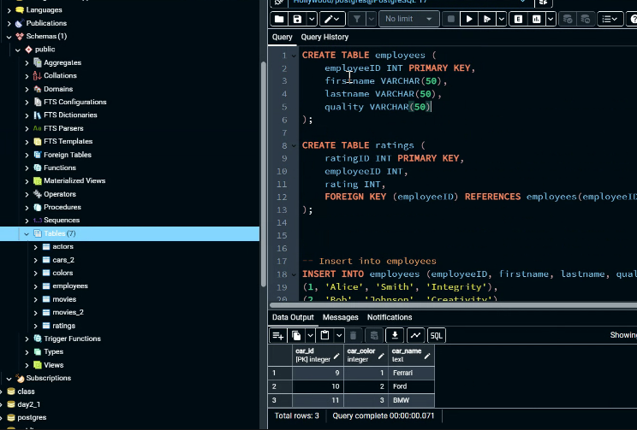

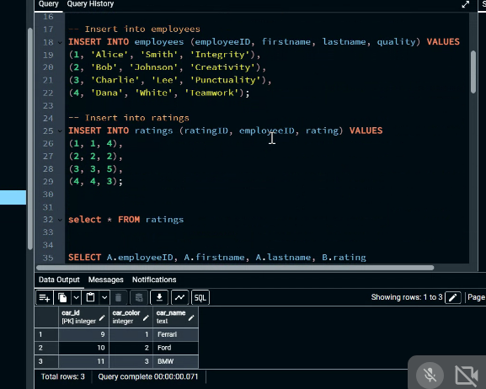
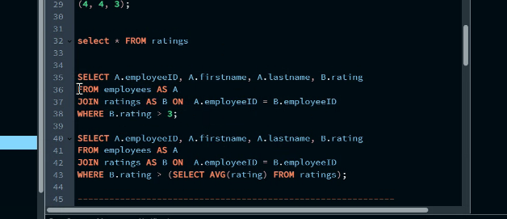
CREATE TABLE employees (
employeeID INT PRIMARY KEY,
firstname VARCHAR(50),
lastname VARCHAR(50),
quality VARCHAR(50)
);

CREATE TABLE ratings (
ratingID INT PRIMARY KEY,
employeeID INT,
rating INT,
FOREIGN KEY (employeeID) REFERENCES employees(employeeID)
);
-- Insert into employees
INSERT INTO employees (employeeID, firstname, lastname, quality) VALUES
(1, 'Alice', 'Smith', 'Integrity'),
(2, 'Bob', 'Johnson', 'Creativity'),
(3, 'Charlie', 'Lee', 'Punctuality'

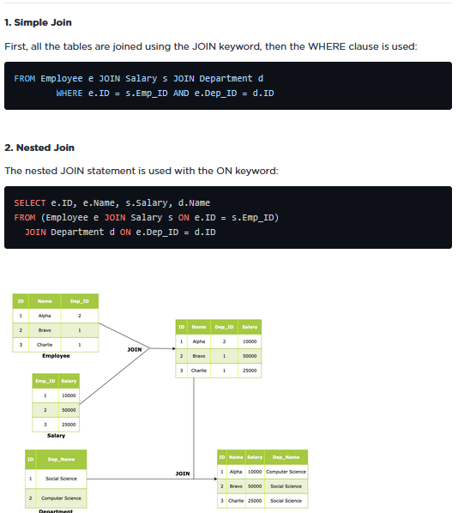

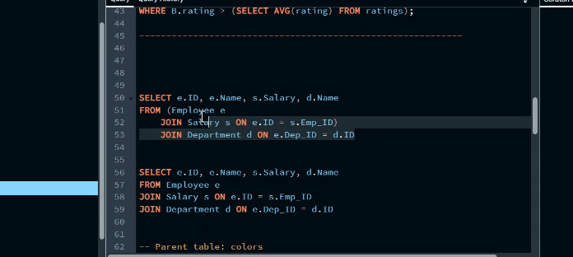

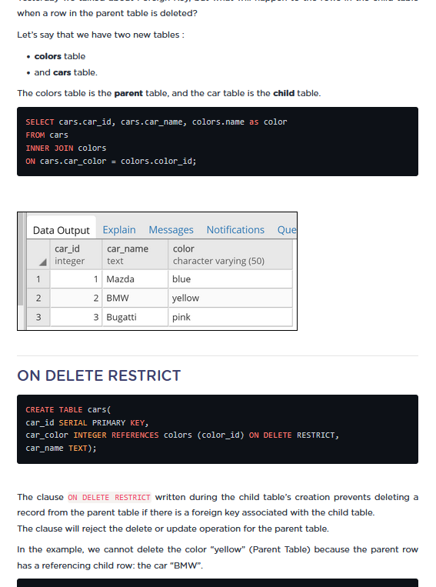
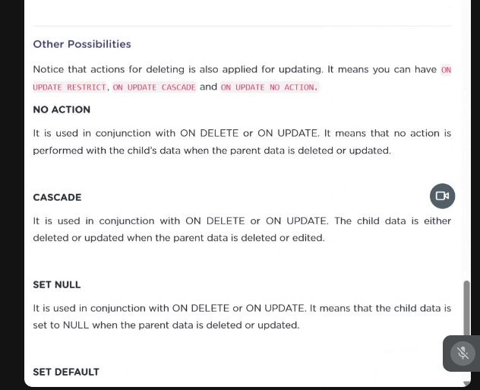
FROM slack
-- Parent table: colors
CREATE TABLE colors (
color_id SERIAL PRIMARY KEY,
name TEXT
);
-- Child table: cars with ON DELETE RESTRICT
CREATE TABLE cars (
car_id SERIAL PRIMARY KEY,
car_color INTEGER REFERENCES colors(color_id) ON DELETE RESTRICT,
car_name TEXT
);
-- Insert into colors
INSERT INTO colors (name) VALUES
('red'),
('blue'),
('yellow'),
('pink');
-- Insert into cars
INSERT INTO cars (car_color, car_name) VALUES
(1, 'Ferrari'),
(2, 'Ford'),
(3, 'BMW'), -- yellow
(4, 'Bugatti'); -- pink
DELETE FROM colors WHERE name = 'yellow'; -- blocked if "BMW" still exists
DROP TABLE IF EXISTS cars;

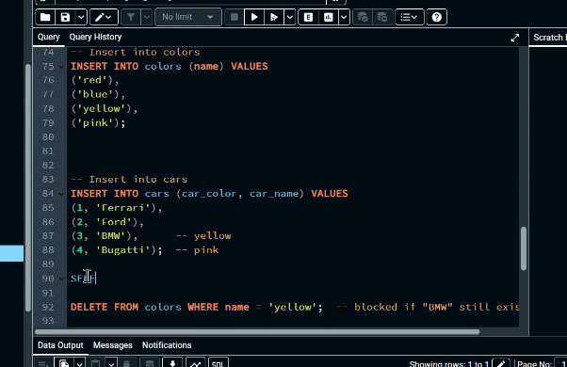

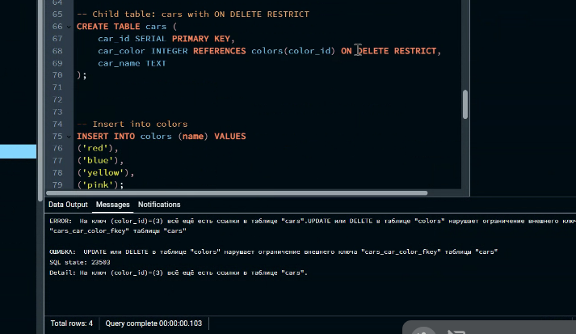

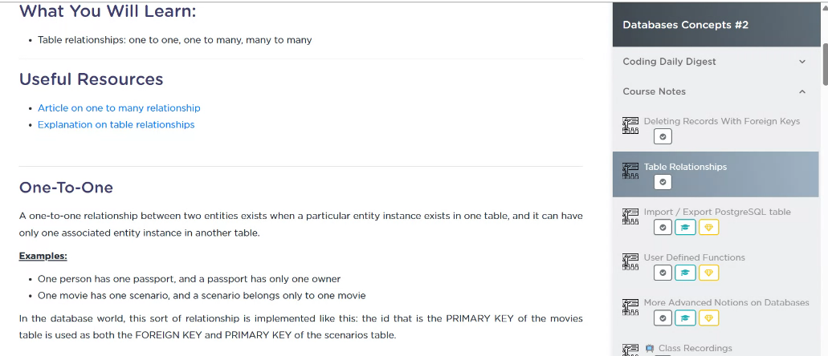

CREATE TABLE users (
user_id SERIAL PRIMARY KEY,
name VARCHAR(50)
);
CREATE TABLE addresses (
user_id INTEGER PRIMARY KEY,
city VARCHAR(50),
street VARCHAR(100),
FOREIGN KEY (user_id) REFERENCES users(user_id)
);
INSERT INTO users (name) VALUES ('Alice'), ('Bob');
INSERT INTO addresses (user_id, city, street) VALUES
(1, 'New York', '5th Avenue'),
(2, 'Los Angeles', 'Sunset Blvd');
SELECT u.name, a.city, a.street
FROM users u
INNER JOIN addresses a ON u.user_id = a.user_id;

